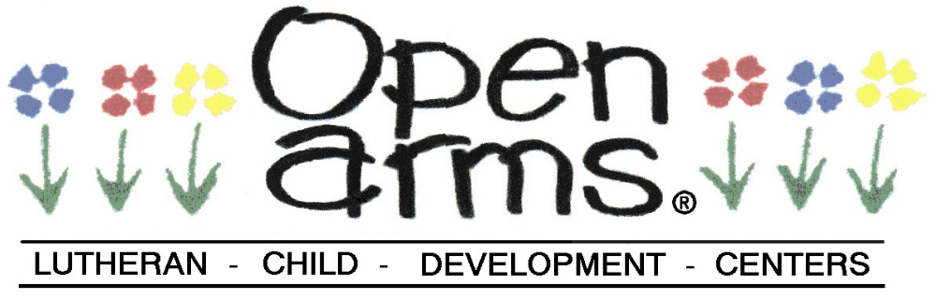

Dear Parents,

We would like your permission to take pictures of your child’s various activities during the day. We would like to share their fun and activities with our congregation in our monthly newsletter, our website, and/or for classroom purposes. No personal information about your child will be publicly published (name, age, etc). If you have any questions, please ask in the office.

Please fill in your child’s name, circle whether you give permission for each of the possible uses, and sign.

Name of Child ___________________________

Monthly Newsletter yes no
Website yes no
Classroom Purposes yes no
Closed Group Social Media Yes no

Parent Signature_______________ Date_________

